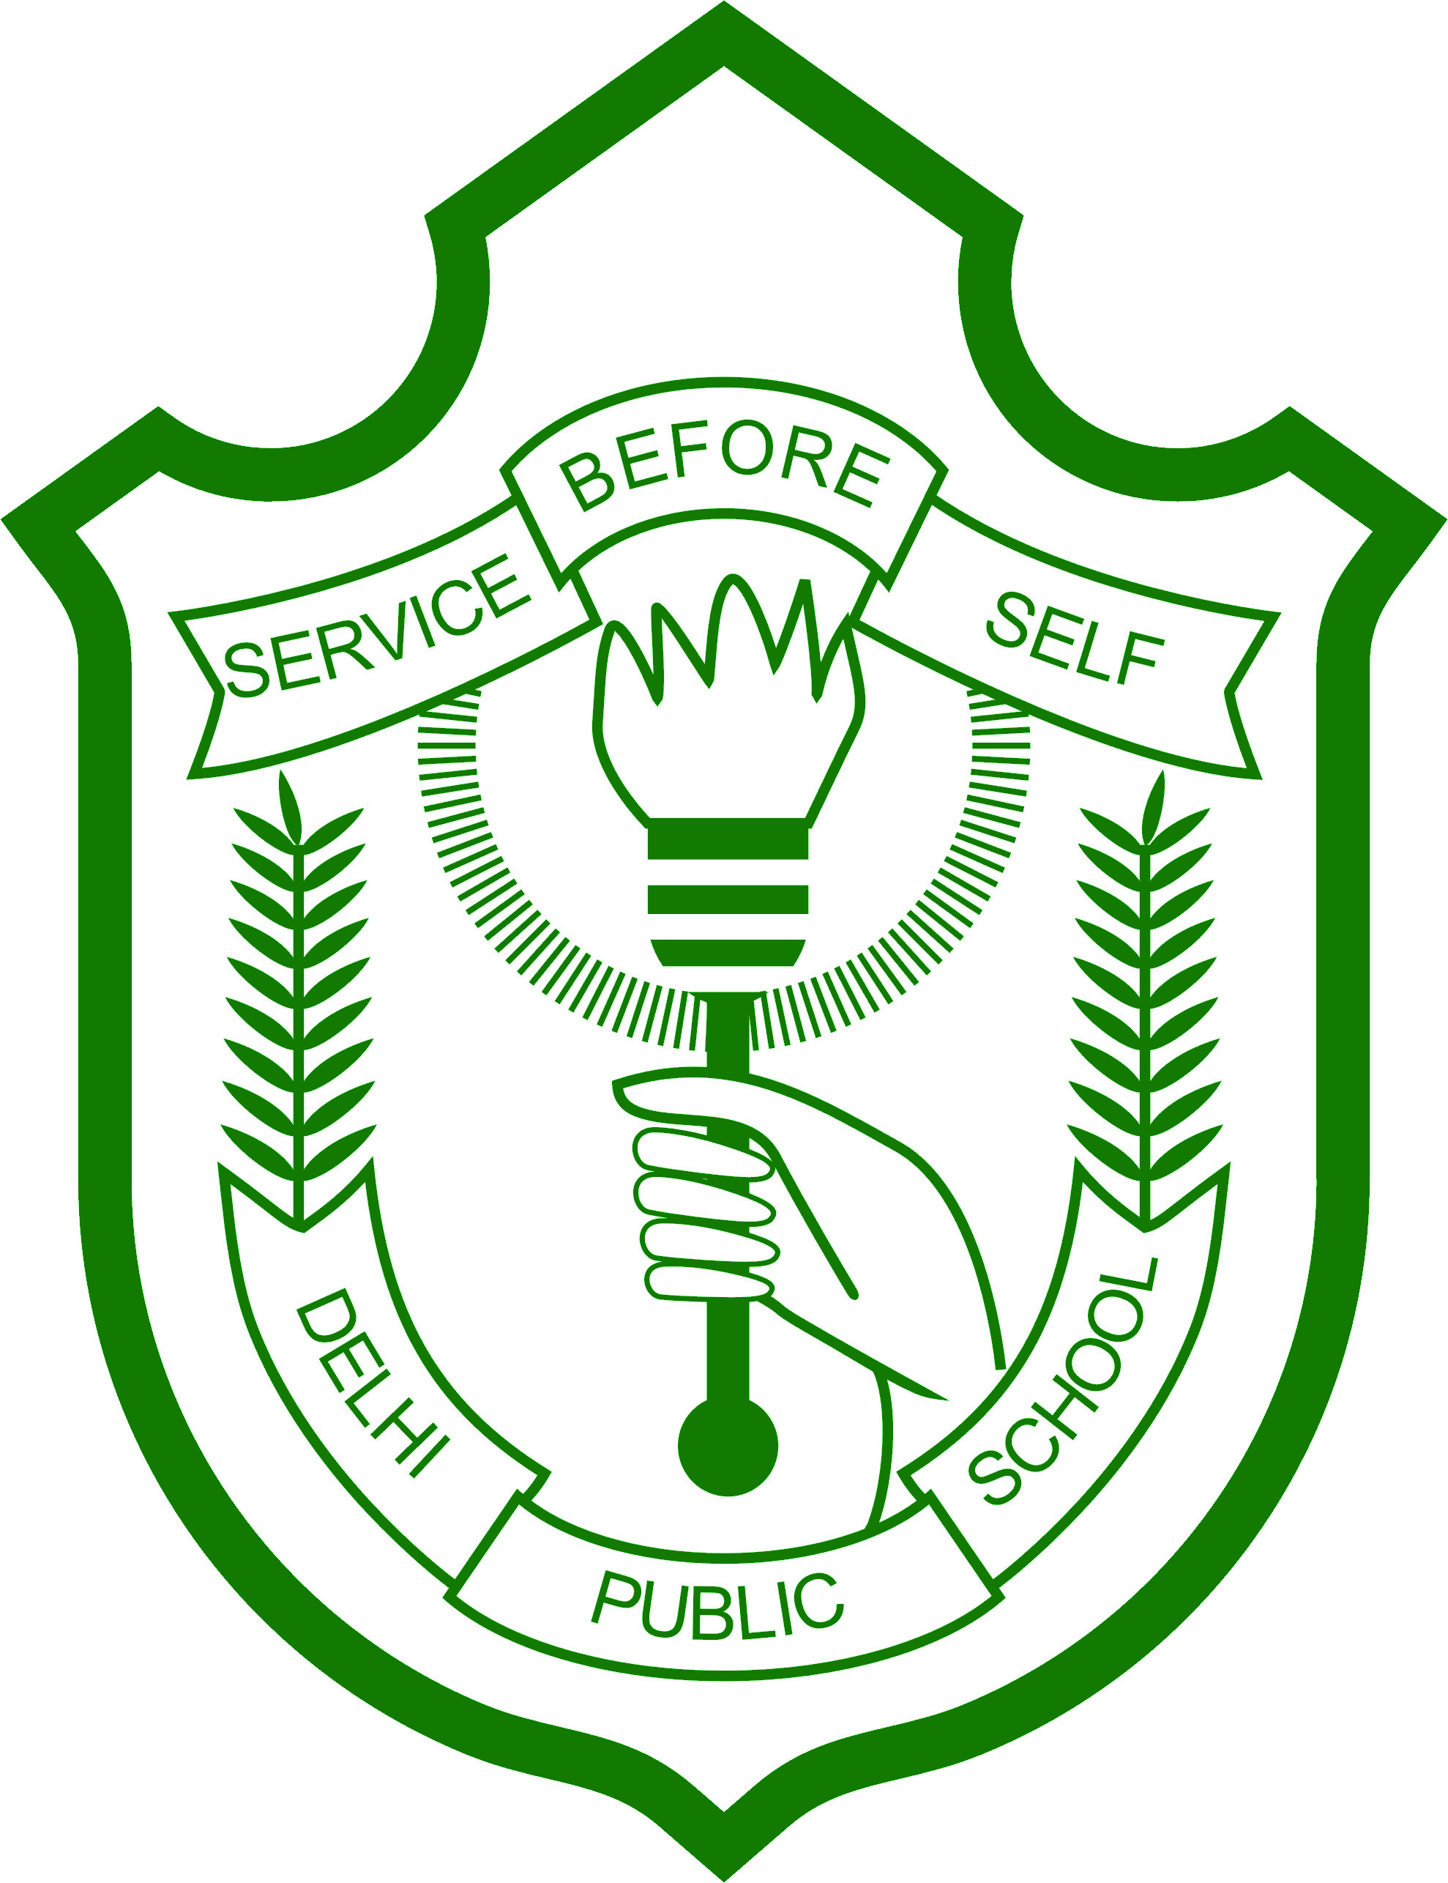
DELHI PUBLIC SCHOOL DHENKANAL
CIRCULAR (Classes Std. II & III) Date: 20/09/2017

Dear Parents,
This is to inform you that as the Terminal Examinations of Classes IV to X are going on; there will be holiday for the students of Classes II & III on 21st & 22nd September, 2017 (i.e. Thursday & Friday). 23rd September (Saturday) is last working day before Autumn Break and the school timing of your ward on 23rd September (Saturday) is as follows:
Reporting time: As usual Departure Time: 10:50am

Anticipating your cooperation.
With regards,

Principal

